MATHEMATICS PAPER 2 PROVISINAL MARKING KEY
- a. $\frac{n^{2}-4}{{\left(n+2\right)}^{2}} ÷\frac{2-n}{n^{2}+2n}.$

$\frac{-(2-n)(n+2)}{(n+2)(n+2)} ×\frac{n(n+2)}{2-n}$ M1, M1
$\frac{-1}{1} ×\frac{n}{1}$ M1
$-n$ A1

b. $\frac{2\sqrt{7} +2\sqrt{45}}{\sqrt{7-}\sqrt{5}}$ $×$ $\frac{\sqrt{7+ }\sqrt{5}}{\sqrt{7}+\sqrt{5}}$ M1
$\frac{2\sqrt{49+}2\sqrt{35-}6\sqrt{35} _6\sqrt{25}}{{\sqrt{7}}^{2}{-\sqrt{5}}^{2}}$ M1
$\frac{2×7-6\sqrt{35} _6×5}{7-5}$
$\frac{14-30-4\sqrt{35} }{7-5}$ M1
$$\frac{-16-4\sqrt{35} }{2}$$
$-8-2\sqrt{35}$ A1

- a. $\log_{8}{a}-\log_{8}{{\left(\frac{1}{a}\right)}^{2}=2}$
$\log_{8}\left(a÷\frac{1}{a^{2}}\right)=2$ M1
$\log_{8}{a^{3}=2}$ M1
$8^{2}=a^{3}$ M1
$64=a^{3}$
a = 4. A1

b. let $x=1$
Substituting for $x$ in the polynomial:
${\left(1\right)}^{3}-13{\left(1\right)}^{2}+47\left(1\right)-35=0$
$∴$ $x-1$ is a factor. M1
Using long division, the quotient is $x^{2}-12x+35.$ M1 M1
$x^{2}-12x+35=\left(x-5\right)\left(x-7\right).$ M1
$∴$ $x^{3}-13x^{2}+47x-35=(x-1)\left(x-5\right)\left(x-7\right)$
$x^{3}-13x^{2}+47x-35=0$ or $\left(x-1\right)\left(x-5\right)\left(x-7\right)=0$ M1
$x-1=0, x-5=0, x-7=0.$
$x=1, x=5, x=7.$ A1

3. a. $S_{1}=$ $10-$ $\frac{10}{2^{1}}$ M1
= 10-5
= 5
$S_{2}=10-\frac{10}{2^{2}}$ M1
= 10$-\frac{10}{4}$
= $\frac{15}{2}$
2 nd term = $\frac{15}{2}-5$ M1
= $\frac{5}{2}$ A1

$\frac{5}{7}$ W
b. $\frac{2}{5}$ T $\frac{2}{7}$ F

$\frac{3}{5}$ NT $\frac{1}{5}$ W M1 M1 M1

$\frac{4}{5}$ F
Probability of win = $\frac{2}{5}×\frac{5}{7}+\frac{3}{5}×\frac{1}{5}$ M1 M1
= $\frac{2}{7}+\frac{3}{25}$
= $\frac{61}{175}$ A1

4. a. $\left(4x-3\right)\left(x-3\right)=259$ M1
${4x}^{2}-15x-250=0$ M1
${4x}^{2}+25x-40x-250=0$
$\left(x-10\right)\left(4x+25\right)=0$ M1
$x=10,$ $x=-6.25$
Son’s ages 10 years. A1
Father’s ages 10 $×$ 4 = 40 years. A1

b.
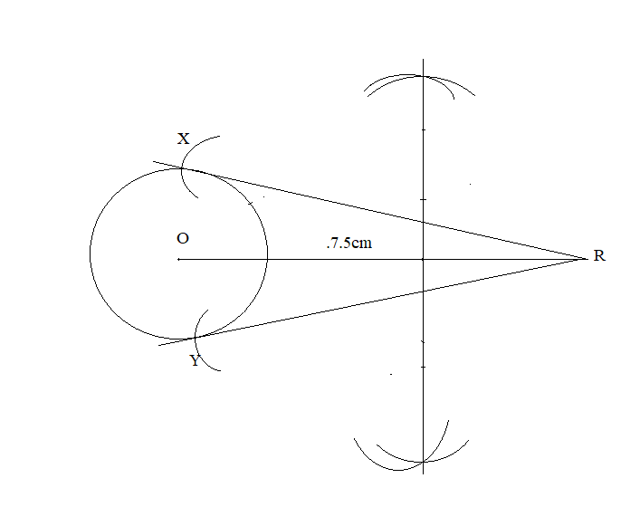
< XRY = 450 M1 M1 M1 M1 A1
5. a.
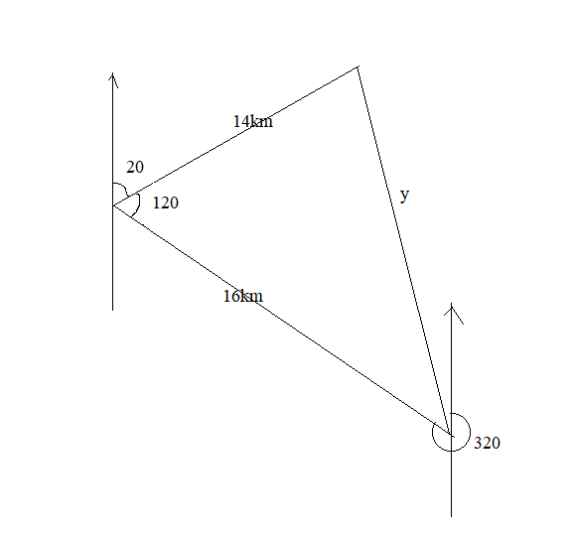

$y^{2}={16}^{2}+{14}^{2}-2×16×14×$cos120⁰. M1
= 256+196+224 M1
= 676
$y^{2}=676$ M1 M1
$y=26$ km A1

b. C = $\frac{k}{n}+bn^{2}$ (n and k are constants)
$12000=k+b$……………….1 M1
$20000=\frac{k}{2}+4b$
$40000=k+8b$………………2 M1
Using elimination method, -7b = -28000
b = 4000
then substituting for b in 1, 12000=k+4000
k = 8000 M1

Relationship:
C = $\frac{8000}{n}+4000n^{2}$ M1
C = $\frac{8000}{5}+4000×25$ M1
= 1600+100000
= K 101600. A1

6. a.
a

b c

b+c = 90⁰ (rad perpendicular to tan) M1
a+b +90⁰=180⁰ (< sum in $∆$) M1
a+b= 900 M1
a=c ( <s in alt seg) A1
^{(proved)}

^{b. To find angle BEN:}
${\left(EN\right)}^{2}={12}^{2}+{10}^{2}$ ^{M1 M1}
⁼ ¹⁴⁴⁺¹⁰⁰
^{EN =} $\sqrt{244}$
${\left(BN\right)}^{2}={10}^{2}-5^{2}$ ^{M1 M1}
⁼ ¹⁰⁰⁻²⁵
^{BN =} $\sqrt{75}$

B
$\sqrt{75}$ cm
E N
$\sqrt{244}$ cm
tanE = $\frac{\sqrt{75}}{\sqrt{244}}$ M1
tanE = 0.554
< BEN = 28. 99⁰. A1

Section B (60 marks)
7. $let 2^{a}=b$ M1
${8b}^{2}-6b-b+1=0$ M1 M1 M1
$\left(8b-1\right)\left(b-1\right)=0$
$b=\frac{1}{8}$, $b=1$ M1 M1
$2^{a}=\frac{1}{8}$, $2^{a}=2^{0}$ M1 M1
$2^{a}=2^{-3}$
$a=-3, a=0$ M1 A1

8. $y=2x-3$ M1
${4x}^{2}-x\left(2x-3\right)-{\left(2x-3\right)}^{2}=9$ M1 M1
${2x}^{2}+3x-{4x}^{2}+12x-9-9=0$ M1 M1
${-2x}^{2}+15x-18=0$
$\left(x-6\right)\left(-2x+3\right)=0$ M1 M1
$x=6$ or $1.5$

$$x$$ | 6 | 1.5
$$y$$ | 9 | 0
M1 M1 A1

9. a.

N T
40+x 17-x
16-x x 15-x 28+x
19+x
M

M1 M1 M1 M1 M1 M1 A1

b. $40+x+17-x+x+16-x+15-x+28+x+19+x=135$
$x+132=135$
$x=135-132$
$x=3$ (3 customers buys all the papers) M1 M1 A1

10. a.
Marks | 1-5 | 6-10 | 11-15 | 16-20 | 21-25
Frequency | 2 | 7 | 10 | 6 | 3
Midpoint | 3 | 8 | 13 | 18 | 23
M1 M1 A1
b. Median class = $\frac{n}{2}$
= $\frac{28 }{2}$ =14 M1 A1
14 falls on 11-15 class, therefore the median class is 11-15.

c.
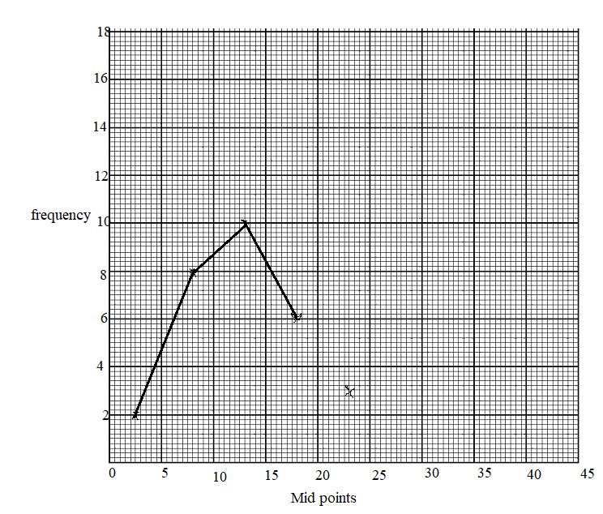
M1 M1 M1 M1 A1

11. $y=x^{3}-6x-1.$
$$x$$ | -$3$ | -$2$ | -$1$ | 0 | 1 | 2 | 3
$$y$$ | -10 | 3 | 4 | -1 | -6 | -5 | 8

M1 M1
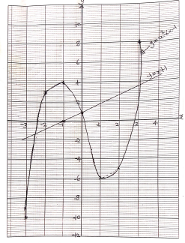

$y=x+1$
$$x$$ | 0 | -1
$$y$$ | 1 | 0
M1 M1
$x=-2.6$, 0 and 2.8 A1

12. $x≥4$, $y≥3, x+y≥10, 4x+5y≤60.$ M1 M1
$4x+5y=60$
$$x$$ | 0 | 15
$$y$$ | 12 | 0
M1
$x+y=10$
$$x$$ | 0 | 10
$$y$$ | 10 | 0
M1

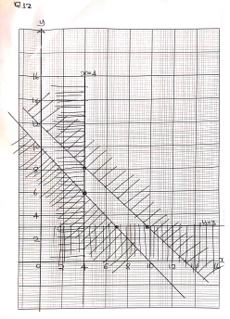

Objective function $f\left(z\right)=x+y$
A $\left(4, 6\right)$
B $\left(4, 8\right)$
C $\left(10, 3\right)$
D $\left(7, 3\right)$
Section A 10 questions and section B 3 questions. A1

